**Mini Project Report on**



**YouTube transcript summarizer**



**Submitted in partial fulfillment of the requirement for the award of the degree of**

**BACHELOR OF TECHNOLOGY**

**IN**

**COMPUTER SCIENCE & ENGINEERING**

**Submitted by:**

**Priyanshi Kamboj 2016928**

***Under the Mentorship of***

**Meenakshi Maindola**

**Designation**



**Department of Computer Science and Engineering**

**Graphic Era (Deemed to be University)**

**Dehradun, Uttarakhand**

**July-2023**



**CANDIDATE’S DECLARATION**

I hereby certify that the work which is being presented in the project report entitled **“YouTube Transcript Summarizer”** in partial fulfillment of the requirements for the award of the Degree of Bachelor of Technology in Computer Science and Engineeringof the Graphic Era (Deemed to be University), Dehradun shall be carried out by the under the mentorship of **Meenakshi Maindola**, Department of Computer Science and Engineering, Graphic Era (Deemed to be University), Dehradun.

Priyanshi Kamboj 2016928

**Table of Contents**

|  |  |  |
| --- | --- | --- |
| **Chapter No.** | **Description** | **Page No.** |
| Chapter 1 | Introduction   * 1. Problem Statement   2. Abstract   3. Need   4. Project Context | **1-3**  1  1  2  3 |
| Chapter 2 | Literature Survey  2.1 Overview  2.2 Use | **4-5**  4  5 |
| Chapter 3 | Methodology  3.1 Text Summarization Techniques  3.2 Project Stages | **7-10**  7  8 |
| Chapter 4 | Result and Discussion  4.1 Terminal  4.2 JS code snippet  4.3 Web Page | **11-12**  11  11  12 |
| Chapter 5 | Conclusion and Future Work  5.1 Conclusion  5.2 Future Scope | **13-14**  13  14 |
|  | References | **15** |

**Table of Figures**

|  |  |  |  |
| --- | --- | --- | --- |
| **Chapter No.** | | **Description** | **Page No.** |
| Chapter 1 | | Fig 1.4.1 Flow Diagram | 3 |
| Chapter 2 | | Fig 2.1.1 Architecture of project | 4 |
| Chapter 3  Chapter 4 | | Fig. 3.2.1 Stages of the project  Fig 3.2.2 Code output  Fig 3.2.3 Display  Fig 4.1.1 Terminal  Fig 4.2.1 JS code snippet  Fig 4.3.1 Before Translation  Fig 4.3.2 After translation | 6  8  9  10  10  11  11 |
|  |

**Chapter 1**

**Introduction**

* 1. **Project Statement:**

Build a YouTube Transcript Summarizer

**1.2 Need**

YouTube recordings are a colossal source of data in today’s time but learning from them could be a intense assignment because it takes a bounty of time in getting the important data from the recordings. Recordings might contain undesirable and wasteful data which can skippable or cannot be so client needs to see it. There number of YouTube clients in 2023 is roughly 2.6 billion and number is quickly expanding each day. On normal, 20000 unused recordings are uploading on YouTube each hour and normal video length is 12 minutes. The number of sharing recordings is expanding exponentially and the client cannot squander their brilliant time in observing the recordings and pick up nothing from those recordings.

Sometimes it gotten to be exceptionally troublesome for observing video which may have longer length of time than anticipated and now and then endeavors become futile if the video doesn’t contain the right data for which the client has looked. It may well be frustrating and time expending to discover for the recordings that contains the exact data with respect to our searched topic.

This summarizer is accommodating for those clients who need to precise

data instead of investing their time in observing the video. Summarizer depicts the transcript of the video within the content arrange so that client can get genuine data and arrangement for their problems.

Transcripts are an great source of data as they contain a literary representation of the sound in a video. Transcript summarization can be accomplished through common dialect handling (NLP) strategies that extricate key expressions

and sentences from the transcript.

The produced rundown can at that point be utilized to supply watchers with a speedy outline of the video substance.

**1.3 Abstract**

Coordinates video information introductions may permit dynamic video browsing. Such introductions give the client with data approximately the substance of a specific arrangement being tried whereas keeping up an imperative message. We propose how to consequently make video rundowns for longer recordings. Our video get to strategy includes two assignments: to begin with, part the video into littler, congruous parts and moment, setting the levels into impacts. Our proposed calculation areas are based on investigation of word recurrence in discourse transcripts. After that the outline is made by selecting the parts with the most noteworthy scores depending on the length of time and these are outlined. We made and conducted a client ponder to check the quality of the rundowns made. Comparisons are made utilizing our proposed calculation and a arbitrary section determination conspire based on scientific investigation of client learning results. At long last, we will see the summarized setting of the video we need to know almost.

**1.4 Project Context**

Coordinates video information introductions may permit dynamic video browsing. Such introductions give the client with data approximately the substance of a specific arrangement being tried whereas keeping up an critical message. We recommend how to naturally make video outlines for longer recordings. Our video get to strategy

involves two assignments: to begin with, part the video into littler, consistent parts and moment, setting the levels into impacts. Our proposed calculation areas are based on investigation of word recurrence in discourse transcripts. After that the rundown is made by selecting the parts with the most noteworthy scores depending on the length of time and these are outlined. We made and conducted a client ponder to check the quality of the outlines made. Comparisons are made utilizing our proposed calculation and a irregular section choice plot based on scientific examination of client learning results. At long last, we are able see the summarized setting of the video we need to know around.

**Chapter 2**

**Literature Survey**

**2.1 Overview**

In this venture, I will be making a Chrome Expansion that will apply to the backend REST API where it'll do NLP and react with a outline of YouTube text.

The utilize of YouTube transcript summarizers has picked up consideration from analysts in later a long time due to the expanding sum of video substance accessible on the stage. This segment presents a writing overview of a few of the past works on YouTube transcript summarizers. ‘Automated Video Summarization Utilizing Discourse Transcript’ by Cuneyt M. Taskiran, Aronon Amir, Dulce B. Ponceleon, Edward J. Delph depicts the compact representations of video information can empower proficient video browsing. They propose the strategy which summarizes the long video naturally.

Their representations give the client important data almost the substance with specific arrangement inspected whereas protecting the basics of the substance. ‘Video Summarization utilizing NLP’ by Sanjana R., Sai Gagana V, Vedhavati K R, Kiran K N proposes an programmed video summarization utilizing Common Dialect Handling (NLP) based calculations. The expanding ubiquity of YouTube gave us the millions of video repository and subsequently there's an increment request for great summarization calculations to summarize different video without misfortune of any exact data of the substance. Their proposed framework depicts the YouTube video transcripts based on which summarized video is created

Millions of recordings are made and shared on the store stages such as YouTube, Reddit, Instagram, etc. It is getting to be challenging errand to spend time on observing such recordings, which may have longer term. Now and then endeavors of observing the recordings may go in unsuccessful on the off chance that we are incapable to extricate our significant data from them but Summarizing transcripts of such recordings can offer assistance us in extricating the important data from the transcript of video.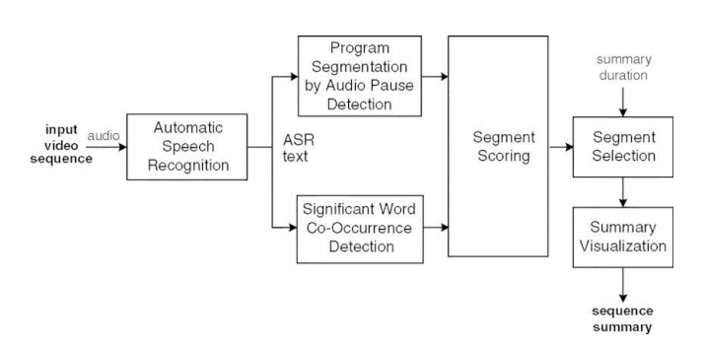

**Fig 2.1.1 Architecture of project**

**2.2 Use**

The utilize of YouTube transcript summarizers has picked up consideration from analysts in later a long time due to the expanding sum of video substance accessible on the stage. This segment presents a writing study of a few of the past works on YouTube transcript summarizers. ‘Automated Video Summarization Utilizing Discourse Transcript’ by Cuneyt M. Taskiran, Aronon Amir, Dulce B. Ponceleon, Edward J. Delph depicts the compact representations of video information can empower productive video browsing. They propose the strategy which summarizes the long video automatically.

The writing overview proposes that YouTube transcript summarization has been drawn nearer utilizing different procedures, counting profound learning models, cross breed approaches, graph-based strategies, and transformer-based dialect models.

**Chapter 3**

**Methodology**

**3.1 Text Summarization Techniques**

Most strategies for video summarization don't make utilize of one of the foremost critical sources, the talked content or the natural-language . The strategies utilized in content summarization may be generally separated into two groups:

• Measurable examination:- In these strategies, rather than utilizing normal dialect understanding strategies, different highlights are extricated from the content which were appeared to be connected with the “abstract worthiness” of a sentence, and the positioning is done employing a combination of these highlights.

• Characteristic Dialect Preparing (NLP) examination:- based on information-extraction methods. This worldview, making utilize of methods from counterfeit insights, involves performing a point by point semantic investigation of the source content to construct a source representation outlined for a specific application.

**3.2 Project Stages**

The project consists of the following stages:-

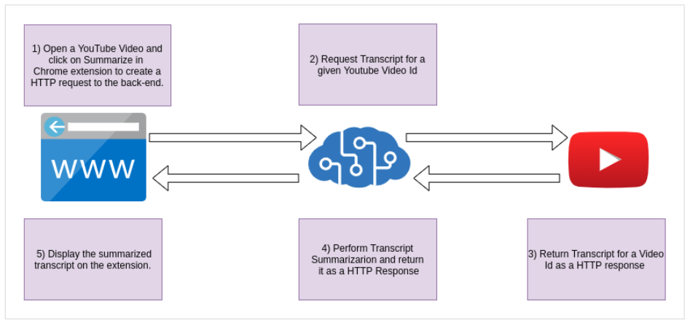

**Fig. 3.2.1 Stages of the project**

This venture includes distinctive API’s such as Carafe API for testing, Python API for getting YouTube video and utilizes distinctive dialects and system such as HTML, CSS and JavaScript for creating the expansion for the net browser. The procedures utilized in content summarization are Characteristic Dialect Preparing (NLP) examination based on information-extraction procedures. This approach, utilizing fake insights procedures, includes a comprehensive examination of the source text's meaning to build a source representation for a particular application.

**3.3 Steps involved**

Step1:- Beginning with backend

APIs changed the way we construct applications, there are endless illustrations of APIs within the world, and numerous ways to structure or set up your APIs. In this milestone, we are aiming to see how to make a back-end application registry and structure it to work with the specified records. We are reaching to confine the back-end of the application to maintain a strategic distance from clashing conditions from other parts of the project.

You are anticipated to initialize the back-end parcel of your application with the specified kettle plate as well as the dependencies.

Step 2:- Get transcript for a given video

You will utilize the python API which permits you to get to text / video film given by YouTube. It also works with auto-generated subtitles, bolsters subtitle interpretation, and does not require a headless browser like other arrangements outlined for Selenium!

You ought to be able to download the script with the assistance of the work done which we are going utilize afterward as the establishment of the NLP processor bolster into the pipeline.

Step 3:- Perform Content Summarization

Text summarizing is the errand of decreasing content parts into a brief outline that stores the substance of key data and full meaning. There are two distinctive methods used to summarize the text:

• Elite Rundown: This can be where the demonstrate recognizes key sentences and expressions from the first content and avoids as it were those.

• Abstractive Shortened form: The demonstrate produces a totally distinctive content shorter than the initial, shaping modern sentences in a better approach, like humans.

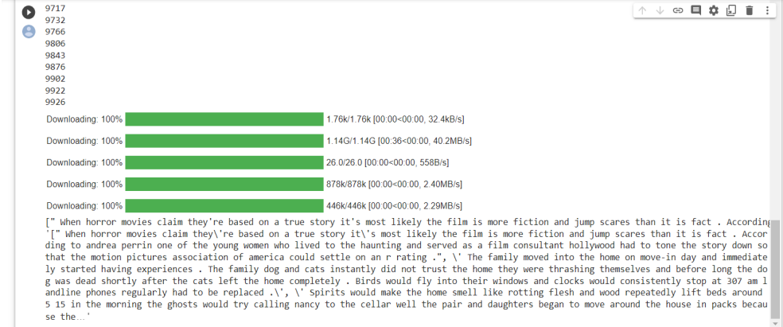

**Fig 3.2.2 Code output**

Step 4:- Make REST API endpoint

The another step is to characterize the assets that will be uncovered by this backend benefit. Typically an amazingly basic application, we as it were have a single endpoint, so our as it were asset will be the summarized text.

You ought to be able to form a last point to summarize YouTube video reports and test the reaction with distinctive video URLs.

Step 5:- Getting begun with chrome extension

Extensions are little computer program programs that customize the browsing involvement. Empowers clients to customize Chrome usefulness and behavior inclinations. See built on web technologies such as HTML, CSS and JavaScript. In this epic, we are you'll see how to form a prescribed Chrome application direct and arrange it to work with the specified files.

Step 6:- Construct a Client Interface for Expansion Popup

We require a client interface so that the client can associated with the popups which are one of a few sorts of client interface that a Chrome extension can give. They as a rule show up upon clicking the expansion symbol within the browser toolbar.

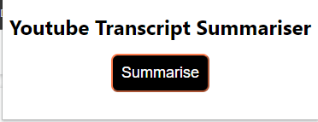

**Fig 3.2.3 Display**

Step 7:- Show Summarized transcript

We will include usefulness to permit the expansion to associate to the repeating server utilizing HTTP REST API calls.

The visual interface of the client ought to be able to show a outline content at the ask of the client.

**Chapter 4**

**Result and Discussion**

**4.1 Terminal**

After compiling the terminal will look like:-

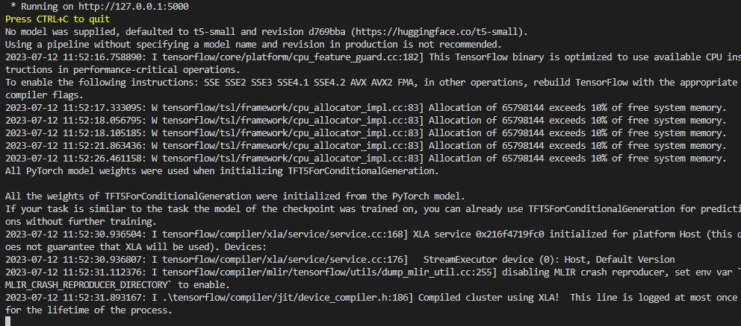

**Fig 4.1.1 Terminal**

**4.2 JavaScript code snippet**

This JavaScript code is responsible for the alert box after clicking on extension which will show us the translation.

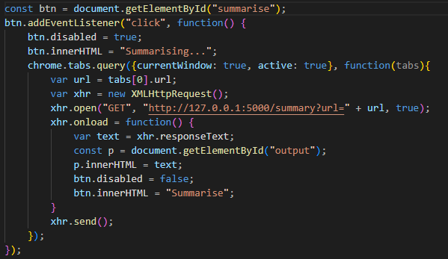

**Fig 4.2.1 JS code snippet**

**4.3 Web page**

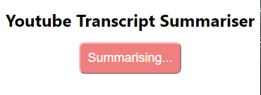

**Fig 4.3.1 Before Translation**

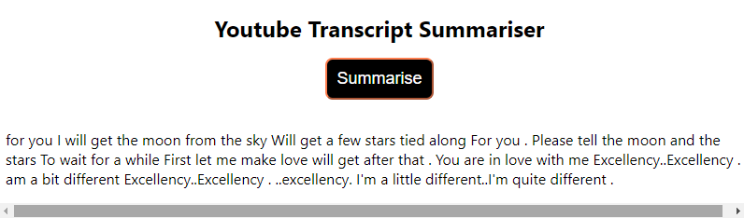

**Fig 4.3.2 After translation**

**Chapter 5**

**Conclusion and Future Work**

**5.1 Conclusion**

The proposed extend could be a YouTube transcript summarizer that utilizes a Google Chrome expansion to get to the transcript of a video and summarize it utilizing Python API and transformers bundle. When the client clicks the summarize button on the Chrome expansion webpage, the framework accesses the transcript and produces an outline that's at that point shown on the expansion webpage. This venture offers a noteworthy time-saving arrangement for users by giving a summary of the video without the ought to observe the whole video. It moreover makes difference clients to distinguish any improper or hurtful substance some time recently observing the video. Besides, the venture offers an great client interface involvement by utilizing Chrome expansions. Clients can effortlessly get the summarized content without having to duplicate and glue the video URL into third-party applications or terminals.

It is critical to get it associations between distinctive innovation and to account for conceivable bugs when joining distinctive program bundles into the corpus of a last computer program item.

**5.2 Future Scope**

The field of YouTube transcript summarization is still advancing, and there's a parcel of potential for future investigate and improvement. A few conceivable future scope for YouTube transcript summarizers are:

1. Multi-lingual support: As YouTube may be a worldwide stage with substance in different dialects, there's a requirement for transcript summarizers to back different languages. Future investigate can center on creating transcript summarizers that can summarize transcripts in several dialects.

2. Real-time summarization: Real-time summarization can be valuable for live occasions or news broadcasts. Future inquire about can center on creating summarizers that can summarize the transcript in real-time.

3. Consolidating client criticism: Client criticism can be utilized to progress the quality of the rundown produced by the transcript summarizer. Future inquire about can center on creating summarizers that can join client criticism to make strides the exactness and pertinence of the summary.

4. Picture and video investigation: The utilization of picture and video investigation procedures can make strides the precision and pertinence of the outline created by the transcript summarizer. Future investigate can center on creating summarizers that can analyze pictures and recordings to produce more enlightening outlines.

5. Summarization based on client inclinations: Diverse clients may have diverse inclinations for the sort of outline they need. Future research can center on creating summarizers that can create personalized rundowns based on the user's preferences.

6. Assessment measurements: There's a requirement for way better assessment measurements to degree the quality of the rundowns created by the transcript summarizer.

In conclusion, there's a parcel of potential for future investigate and advancement within the field of YouTube transcript summarization. The improvement of unused strategies and advances can lead to more exact and pertinent outlines, making it less demanding for clients to extricate data from YouTube recordings.

**References**

[1] Jiri Fajtl, Hajar Sadeghi Sokeh, Vasileios Argyriou, Dorothy Monekosso , and Paolo Remagnino: Summarizing Videos with Attention In: Proceedings of the ICLR. Vol. 5 (2019).

[2] Kaiyang Zhou, Yu Qiao, Tao Xiang : Deep Reinforcement Learning for Unsupervised Video Summarization In: Diversity-Representativeness Reward 2018, Association for the Advancement of Artificial Intelligence ([www.aaai.org](http://www.aaai.org)).

[3] Mrigank Rochan, Linwei Ye, and Yang Wang: Video Summarization Using Fully Convolutional Sequence Networks In: International Conference on Learning Representations (2018).

[4] <https://www.crio.do/projects/python-youtube-transcript/>

[5] <https://pypi.org/project/youtube-transcript-api/>

[6]<https://www.thepythoncode.com/article/text-summarization-using-huggingfacetransformers-python>

[7] Ferman A.M. and Tekalp A.M. Two-stage hierarchical video summary extraction to match low-level user browsing preerences. IEEE Trans. Multimedia, 5(2):244–256, 2003.

[8] P.Sushma, Dr.S.Nagaprasad, Dr. V. Ajantha Devi. Youtube: Bigdata Analytics using Hadoop and Map Reduce in International Journal of Engineering Research in Computer Science and Engineering (IJERCSE), vol 5, Issue 4, April 2018